**BIKE AUTOMATION**

**PROJECT REPORT**

**INTRODUCTION**

Bike automation is one of the least explored fields in sensor integration. Our esteemed team members put out their heads together and designed a very basic yet useful application. A raspberry pi controlled and partially autonomous bike system is presented in this report. It highlights the idea to develop a prototype of bike whose features can be easily automatically accessed in different circumtances. The bike will have limited automation features like automatic stand detection, automatic indicator lights, etc. The main goal here is to minimize the work of human power and ensure high performance driving. At the same time the bike will assure comfort and convenience to the controller by providing automatic lights and automatic horns. The bike is so designed that in case the bike falls while driving, the engine is automatically turned off. A miniature bike including the above features has been developed which showed optimum performance in a simulated environment. The system mainly consists of a Raspberry Pi 3 B+, ultrasonic sensor, light dependent resistor (LDR) module, buzzer, gyroscope and LEDs. The proposed system is very cheap and very efficient in terms of automation.

**RASPBERRY PI**

The Raspberry Pi is a credit-card-sized computer that plugs into your TV and a keyboard. It is a capable little computer which can be used in electronics projects, and for many of the things that your desktop PC does, like spreadsheets, word processing, browsing the internet, and playing games. It also plays high-definition video. We want to see it being used by adults and children all over the world to learn programming and digital making.

The Raspberry Pi 3 Model B+ is the latest product in the Raspberry Pi 3 range.

* Broadcom BCM2837B0, Cortex-A53 (ARMv8) 64-bit SoC @ 1.4GHz
* 1GB LPDDR2 SDRAM
* 2.4GHz and 5GHz IEEE 802.11.b/g/n/ac wireless LAN, Bluetooth 4.2, BLE
* Gigabit Ethernet over USB 2.0 (maximum throughput 300 Mbps)
* Extended 40-pin GPIO header
* Full-size HDMI
* 4 USB 2.0 ports
* CSI camera port for connecting a Raspberry Pi camera
* DSI display port for connecting a Raspberry Pi touchscreen display
* 4-pole stereo output and composite video port
* Micro SD port for loading your operating system and storing data
* 5V/2.5A DC power input
* Power-over-Ethernet (PoE) support (requires separate PoE HAT)

**­­­** 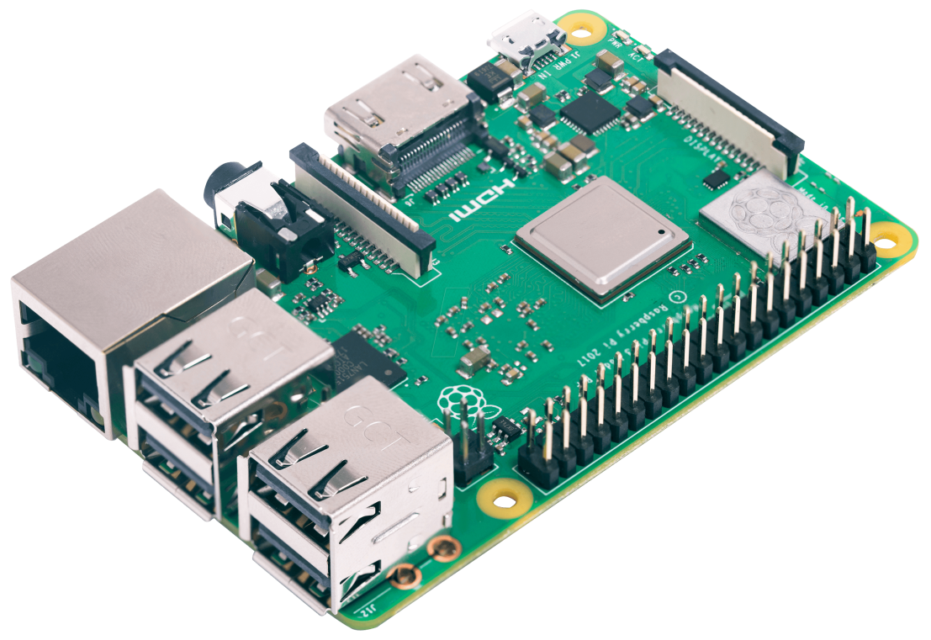

**PROJECT INSIGHT**

We have designed a set of modules to enhance the functionality of pre-existing features so as to improve the safety of the controller. We have introduced the following applications to our project.

**AUTOMATIC INDICATORS**

We introduced a gyroscope sensor that provides us the acceleration in various directions. Accordingly, we computed the direction the vehicle was turning into thus automatically turning on the indicators of that side.

**AUTOMATIC HORN**

We have used an ultrasonic sensor to measure the distance between an upcoming object and the front end of the bike. A buzzer is programmed to automatically generate a sound beep as soon as an object comes in close proximity.

**AUTOMATIC HEADLIGHTS**

We have used an LDR sensor to turn the headlight automatically on the moment it gets dark. All connections have been programmed parallel so that the original function stays true.

**AUTOMATIC STAND INDICATOR**

The most common issue faced by various two wheeler vehicle owners is that they forget to check the orientation of the bike stand. To tackle this everyday problem, we have introduced an automatic bike stand indicator lights. When the stand has been lifted off, the controller will see a green light which represents that it’s safe to move. Otherwise the red light will glow to indicate that it’s advisable to stop and shift the stand first.

**FUEL TANK INDICATOR**

We have also introduced a system where the fuel tank level can be detected using an ultrasonic sensor and the moment the fuel level goes below a certain length, a message is shown on the LCD display giving a warning shot.

**AUTOMATIC KILL SWITCH ACTIVATOR**

We devised a very important safety feature wherein, the Kill Switch of the bike is automatically switched on the very moment the bike tilts over a particular level using a relay switch and a gyroscope sensor to compute the same.

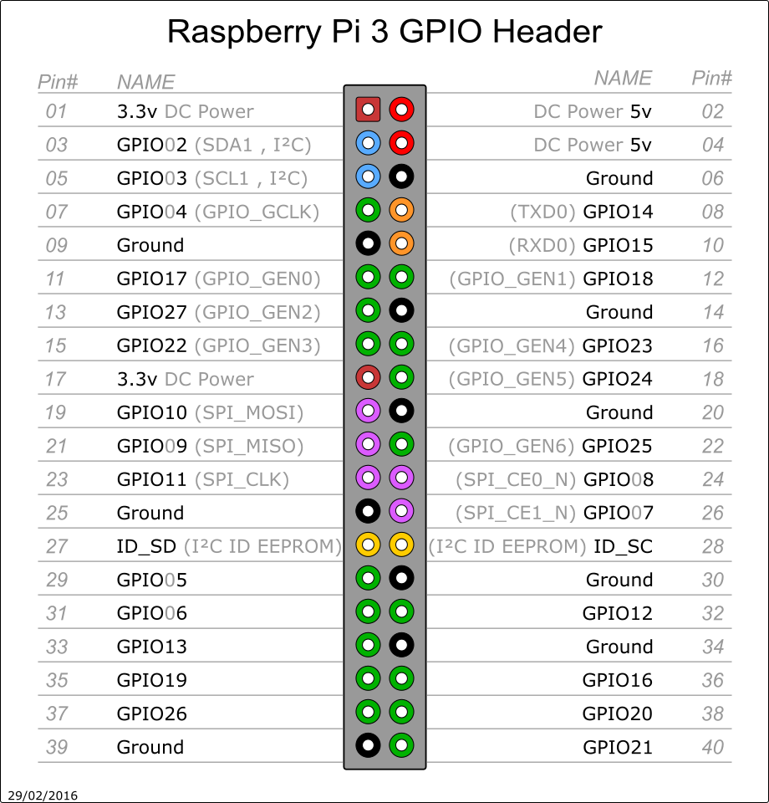

**SENSORS USED**

**ULTRASONIC SENSOR**

**What are Ultrasonic Sensors?**

As the name indicates, ultrasonic sensors measure distance by using ultrasonic waves.

The sensor head emits an ultrasonic wave and receives the wave reflected back from the target. Ultrasonic Sensors measure the distance to the target by measuring the time between the emission and reception.

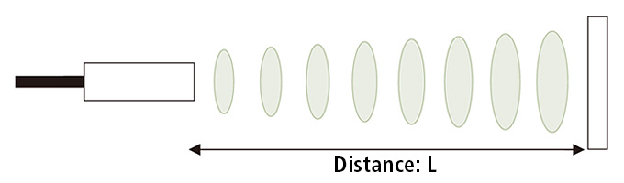

An optical sensor has a transmitter and receiver, whereas an ultrasonic sensor uses a single ultrasonic element for both emission and reception. In a reflective model ultrasonic sensor, a single oscillator emits and receives ultrasonic waves alternately. This enables miniaturization of the sensor head.

**Distance Calculation**

The distance can be calculated with the following formula:

### Distance L = 1/2 × T × C

where L is the distance, T is the time between the emission and reception, and C is the sonic speed. (The value is multiplied by 1/2 because T is the time for go-and-return distance.)

**Advantages of Ultrasonic Sensors**

These are a few ultrasonic sensor advantages that help clarify what applications our sensors are suited for.

1. **Not affected by color or transparency of objects**

Ultrasonic sensors reflect sound off of objects, so the color or transparency has no effect on the sensor’s reading.

1. **Can be used in dark environments**

Unlike proximity sensors using light or cameras, dark environments have no effect on an ultrasonic sensor’s detection ability.

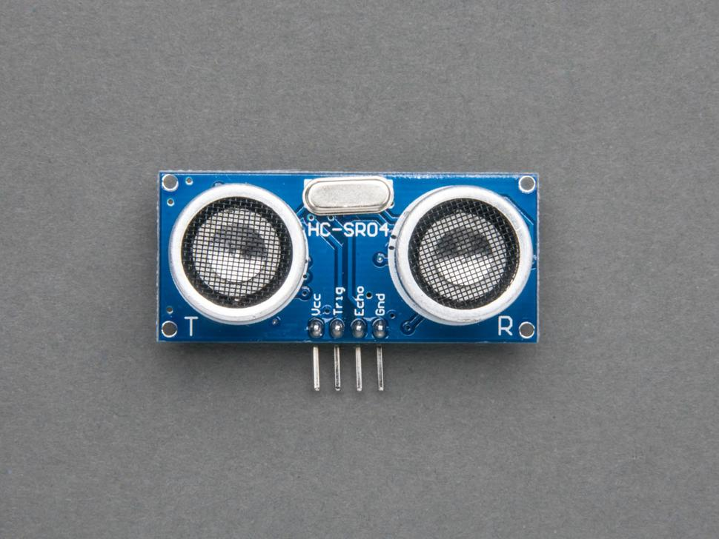

1. **Low-cost option**

These sensors start at Rs. 90. They come fully calibrated and ready to use.

1. **Not highly affected by dust, dirt, or high-moisture environments**

Although these sensors work well in these environments, they can still give incorrect readings with a heavy build-up of dirt or water, especially in extreme conditions.

**Limitations of Ultrasonic Sensors**

We understand that ultrasonic are not suited for every application. Below we go into the *limitations of these sensors*, and how we have overcome some of these problems.

1. **Cannot work in a vacuum**

Because ultrasonic sensors operate using sound, they are completely nonfunctional in a vacuum as there is no air for the sound to travel through.

1. **Not designed for underwater use**

Ultrasonic sensors have not been properly tested in this environment, so they might not work properly.

1. **Sensing accuracy affected by soft materials**

Objects covered in a very soft fabric absorb more sound waves making it hard for the sensor to see the target.

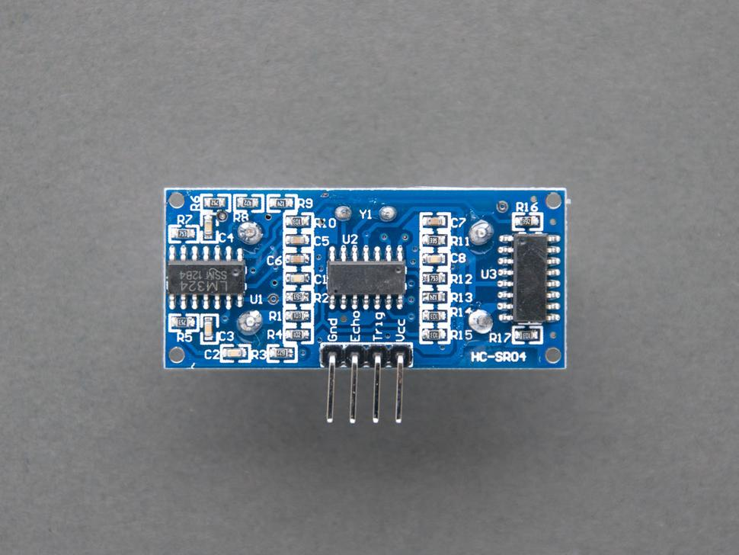

**LIGHT DEPENDENT RESISTOR**

**What is an LDR (Light Dependent Resistor)?**

An LDR is a component that has a (variable) resistance that changes with the light intensity that falls upon it. This allows them to be used in light sensing circuits. Also known as Photo resistors, LDRs are light sensitive devices most often used to indicate the presence or absence of light, or to measure the light intensity. In the dark, their resistance is very high, sometimes up to 1MΩ, but when the LDR sensor is exposed to light, the resistance drops dramatically, even down to a few ohms, depending on the light intensity. LDRs have a sensitivity that varies with the wavelength of the light applied and are nonlinear devices. They are used in many applications but are sometimes made obsolete by other devices such as photodiodes and phototransistors.

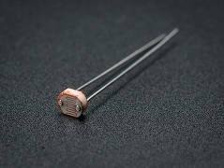 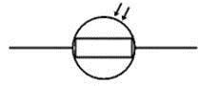

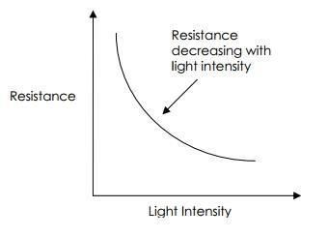

The most common type of LDR has a resistance that falls with an increase in the light intensity falling upon the device (as shown in the image above). The resistance of an LDR may typically have the following resistances:

Daylight= 5000Ω and Dark= 20000000Ω

**Advantages of LDR**

1. **Low price and high variety**

The price of the LDR is less and there are different sizes & shapes which are available in the market. In the practical LDR there are different sizes are available and the most popular size is 100mm phase diameter.

1. **Less supply required**

For the operation of LDR it requires less power and voltage.

1. **Various applications**

LDR has got many applications for example-

* Automatic Street Lights.
* ‎Outdoor Garden Lights.
* In mobile phones for auto brightness and flash.
* Cameras shutter control and flash control
* Burglar alarm circuits

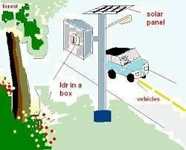 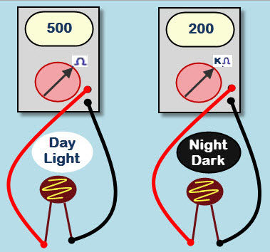

**Limitations of LDR**

1. **Sensitivity**

The sensitivity and resistance range of the LDRs will vary from one device to another. Light dependent resistors have a lower sensitivity than photo diodes and photo transistors. Photo diodes and photo transistors are true semiconductor devices which use light to control the flow of electrons and holes across PN-junctions, while light dependent resistors are passive components, lacking a PN-junction. If the light intensity is kept constant, the resistance may still vary significantly due to temperature changes, so they are sensitive to temperature changes as well. This property makes LDRs unsuitable for precise light intensity measurements.

1. **Latency**

Another interesting property of photo resistors is that there is time latency between changes in illumination and changes in resistance. This phenomenon is called the resistance recovery rate. It takes usually about 10 ms for the resistance to drop completely when light is applied after total darkness, while it can take up to 1 second for the resistance to rise back to the starting value after the complete removal of light. For this reason, the LDR cannot be used where rapid fluctuations of light are to be recorded or used to actuate control equipment. They require a few milliseconds or more to respond fully to the changes in light intensity. They will take few seconds to return to their normal dark resistance once light is removed.

### **Wavelength dependency**

The sensitivity of a photo resistor varies with the light wavelength. If the wavelength is outside a certain range, it will not affect the resistance of the device at all. It can be said that the LDR is not sensitive in that light wavelength range.

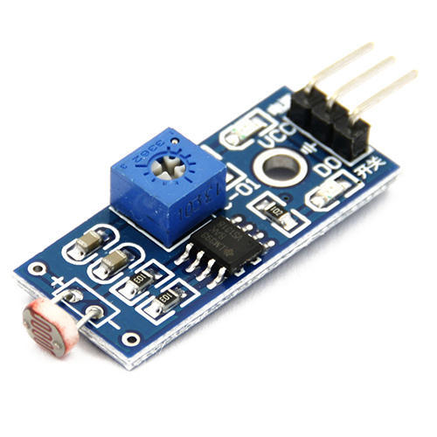 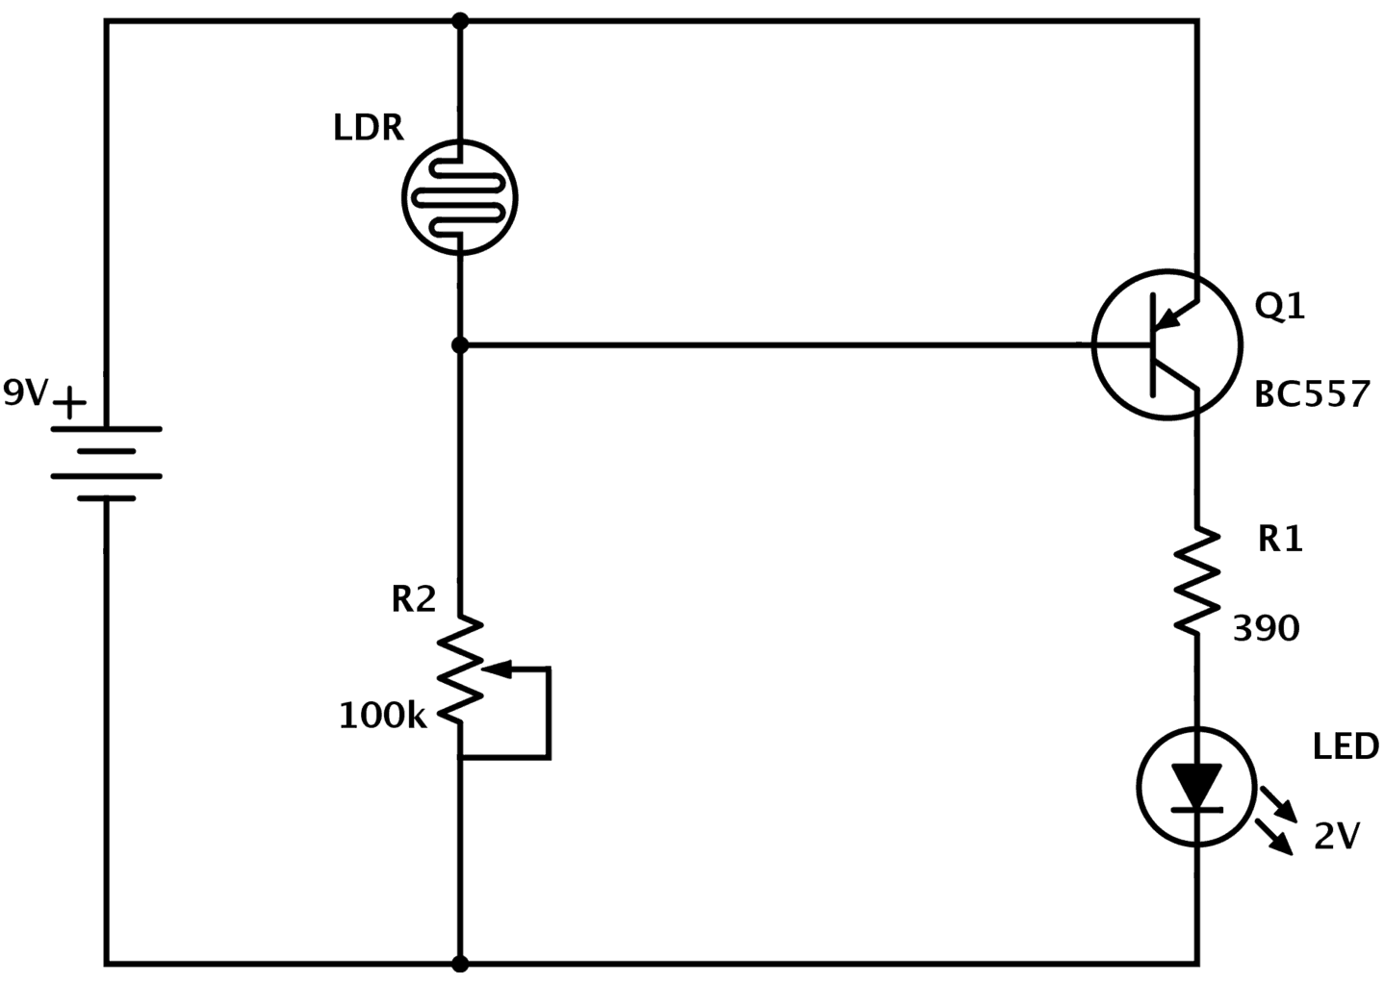

**GYROSCOPE**

**What are gyro sensors?**

Gyro sensors, also known as angular rate sensors or angular velocity sensors, are devices that sense angular velocity.

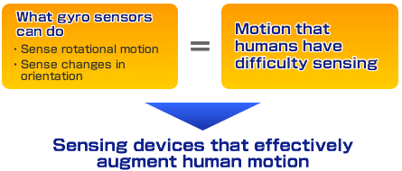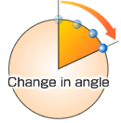

In simple terms, angular velocity is the change in rotational angle per unit of time. Angular velocity is generally expressed in deg/s (degrees per second).

**Gyro sensor types**

Gyro sensors come in a variety of types. Here, different types are plotted by size and performance.

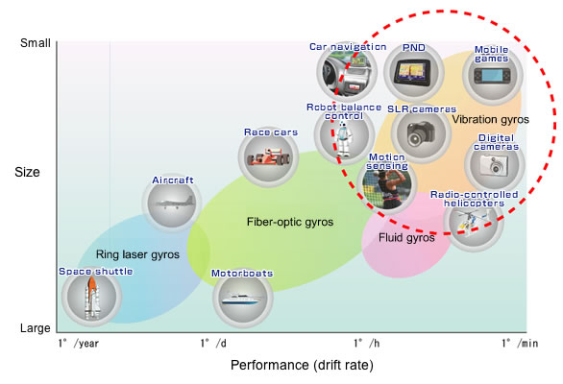

|  |
| --- |
| **Angular velocity sensing** |
| Sense the amount of angular velocity produced.  https://www5.epsondevice.com/en/information/technical_info/img/about_5_arrow.gif Used in measuring the amount of motion itself. Ex.) Checking athletic movement |
| **Angle sensing** |
| Senses angular velocity produced by the sensor's own movement. Angles are detected via integration operations by a CPU. https://www5.epsondevice.com/en/information/technical_info/img/about_5_arrow.gif The angle moved is fed to and reflected in an application. Ex.) Car navigation systems Game controllers Cellular |

|  |
| --- |
| **Control mechanisms** |
| Senses vibration produced by external factors, and transmits vibration data as electrical signals to a CPU. https://www5.epsondevice.com/en/information/technical_info/img/about_5_arrow.gif Used in correcting the orientation or balance of an object. Ex.) Camera-shake correction Vehicle control |

These are three main applications for gyro sensors. Examples of angular velocity in applications:  
• Car navigation systems: ~10 deg/s  
• Vehicle control: ~30 deg/s  
• Camera-shake correction: ~100 deg/s  
• Game controllers: ~300 deg/s  
• Sensing the swing of golf's top players: ~3,000 deg/s

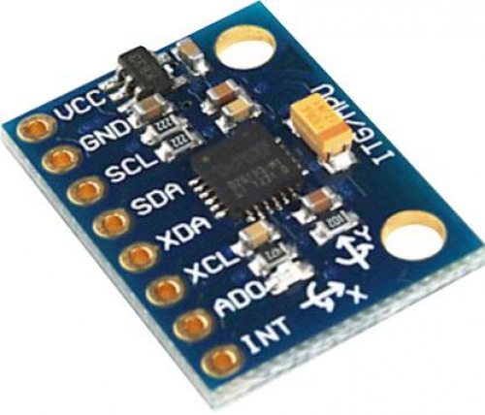

Some uses of gyroscope sensors include GPS, Gaming (with motion censors) or to calibrate compass or practically anything which works when because of rotational movement of phone. With out gyroscope there are some loses of features in your phone:  
 1. You cannot play a game that involves circular motion for instance counter strike.  
 2. With out gyroscope Orientation of the phone Horizontal and vertical orientation of the device may not be sensitive.  
 3. Accelerometer alone will not provide orientation of the smartphone precisely without the help of gyroscope.

**Accelerometer and gyroscope**

Accelerometers in mobile phones are used to detect the orientation of the phone. The gyroscope, or gyro for short, adds an additional dimension to the information supplied by the accelerometer by tracking rotation or twist.

An accelerometer measures linear acceleration of movement, while a gyro on the other hand measures the angular rotational velocity. Both sensors measure rate of change; they just measure the rate of change for different things.

In practice, that means that an accelerometer will measure the directional movement of a device but will not be able to resolve its lateral orientation or tilt during that movement accurately unless a gyro is there to fill in that info.

With an accelerometer you can either get a really "noisy" info output that is responsive, or you can get a "clean" output that's sluggish. But when you combine the 3-axis accelerometer with a 3-axis gyro, you get an output that is both clean and responsive in the same time.

**BUZZER**

**What is a Buzzer?**

A buzzer or beeper is an audio signalling device, which may be mechanical, electromechanical, or piezoelectric (piezo for short). Typical uses of buzzers and beepers include alarm devices, timers, and confirmation of user input such as a mouse click or keystroke.

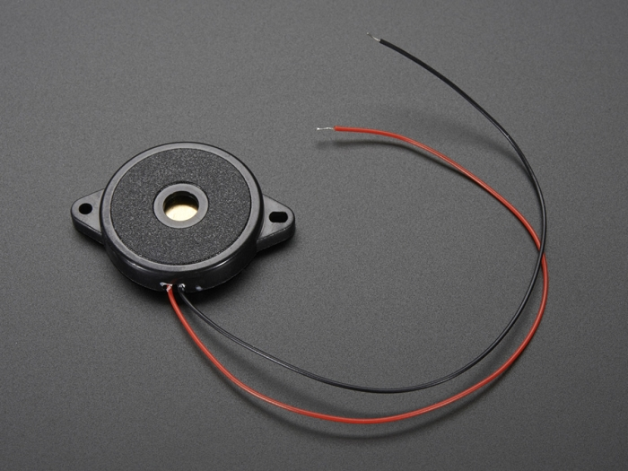

**Types of Buzzers**

1. **Electromechanical**

Early devices were based on an electromechanical system identical to an electric bell without the metal gong. Similarly, a relay may be connected to interrupt its own actuating current, causing the contacts to buzz. Often these units were anchored to a wall or ceiling to use it as a sounding board. The word "buzzer" comes from the rasping noise that electromechanical buzzers made.

1. **Mechanical**

A joy buzzer is an example of a purely mechanical buzzer and they require drivers. Other examples of them are doorbells.

1. **Piezoelectric**

A piezoelectric element may be driven by an oscillating electronic circuit or other audio signal source, driven with a piezoelectric audio amplifier. Sounds commonly used to indicate that a button has been pressed are a click, a ring or a beep.

**Applications of buzzer**

While technological advancements have caused buzzers to be impractical and undesirable, there are still instances in which buzzers and similar circuits may be used. Present day applications include:

* Novelty uses
* Judging panels
* Educational purposes
* Annunciator panels
* Electronic metronomes
* Game show lock-out device
* Microwave ovens and other household appliances
* Sporting events such as basketball games
* Electrical alarms
* Joy buzzer (mechanical buzzer used for pranks)

**OTHER HARDWARE USED**

# Liquid-crystal display

A liquid-crystal display (LCD) is a flat-panel display or other electronically modulated optical device that uses the light-modulating properties of liquid crystals. Liquid crystals do not emit light directly, instead using a backlight or reflector to produce images in color or monochrome. LCDs are available to display arbitrary images (as in a general-purpose computer display) or fixed images with low information content, which can be displayed or hidden, such as preset words, digits, and seven-segment displays, as in a digital clock. They use the same basic technology, except that arbitrary images are made up of a large number of small pixels, while other displays have larger elements.

There are some advantages of liquid crystal display (LCD) which are given below,

* The LCD can be made in large sizes of over 60 inch or 150 cm diagonal.
* It has no geometric distortion.
* It is very compact, thin, and light CRT displays.
* It does not affect by the magnetic fields.
* Due to low power consumption, small heat emitted during operation.
* It is much thinner than a CRT (cathode ray tube) monitor.

There are some disadvantages of liquid crystal display (LCD) which are given below,

* In high temperature environments there is loss of contrast.
* It is relatively bright but not suitable for very brightly environments.
* It consumed a lot of electricity which produce a lot of heat.
* It has individual liquid crystals which cannot complete all block of the backlight.
* From the viewing angle, the color and contrast not consistent.

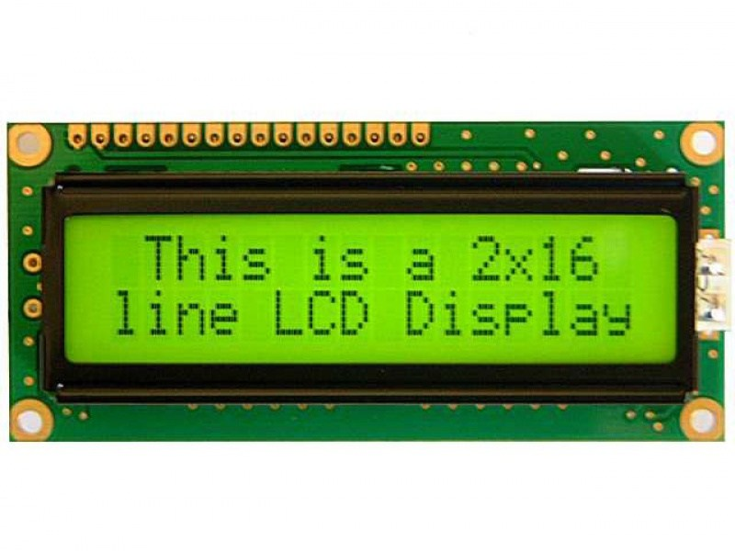

# **Relay Switch**

A relay is an electrically operated switch of mains voltage. It means that it can be turned on or off, letting the current go through or not.

* 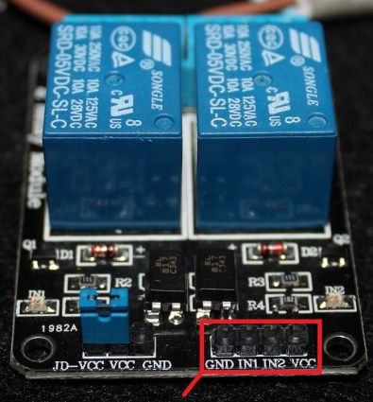**GND**: goes to ground
* **IN1**: controls the first relay.
* **IN2**: controls the second relay.
* **VCC**: goes to 5V

Relays are switches that open and close circuits electromechanically or electronically. Relays control one electrical circuit by opening and closing contacts in another circuit. As relay diagrams show, when a relay contact is normally open (NO), there is an open contact when the relay is not energized. When a relay contact is Normally Closed (NC), there is a closed contact when the relay is not energized. In either case, applying electrical current to the contacts will change their state.

Advantages of Relays

* The complete electrical isolation improves safety by ensuring that high voltages and currents cannot appear where they should not be.
* Relays come in all shapes and sizes for different applications and they have various switch contact configurations.  Double Pole Double Throw (DPDT) relays are common and even 4-pole types are available.  You can therefore control several circuits with one relay or use one relay to control the direction of a motor.
* It is easy to tell when a relay is operating - you can hear a click as the relay switches on and off and you can sometimes see the contacts moving.

##### Disadvantages of Relays

* Their parts can wear out as the switch contacts become dirty - high voltages and currents cause sparks between the contacts.
* They cannot be switched on and off at high speeds because they have a slow response and the switch contacts will rapidly wear out due to the sparking.
* Their coils need a fairly high current to energise, which means some micro-electronic circuits can't drive them directly without additional circuitry.
* The back-emf created when the relay coil switches off can damage the components that are driving the coil.  To avoid this, a diode can be placed across the relay coil, as will be seen in any *Electronics in Meccano* circuits that use relays with sensitive components.

# **Light-emitting diode**

A light-emitting diode (LED) is a two-lead semiconductor light source. It is a p–n junction diode that emits light when activated. When a suitable current is applied to the leads, electrons are able to recombine with electron holes within the device, releasing energy in the form of photons. This effect is called electroluminescence, and the colour of the light (corresponding to the energy of the photon) is determined by the energy band gap of the semiconductor. LEDs are typically small (less than 1 mm2) and integrated optical components may be used to shape the radiation pattern.

A P-N junction can convert absorbed light energy into a proportional electric current. The same process is reversed here (i.e. the P-N junction emits light when electrical energy is applied to it). This phenomenon is generally called electroluminescence, which can be defined as the emission of light from a semiconductor under the influence of an electric field. The charge carriers recombine in a forward-biased P-N junction as the electrons cross from the N-region and recombine with the holes existing in the P-region. Free electrons are in the conduction band of energy levels, while holes are in the valence energy band. Thus the energy level of the holes is less than the energy levels of the electrons. Some portion of the energy must be dissipated to recombine the electrons and the holes. This energy is emitted in the form of heat and light.

The electrons dissipate energy in the form of heat for silicon and germanium diodes but in gallium arsenide phosphide (GaAsP) and gallium phosphide (GaP) semiconductors, the electrons dissipate energy by emitting photons. If the semiconductor is translucent, the junction becomes the source of light as it is emitted, thus becoming a light-emitting diode. However, when the junction is reverse biased, the LED produces no light and—if the potential is great enough, the device is damaged.

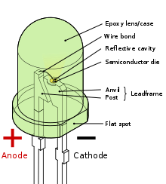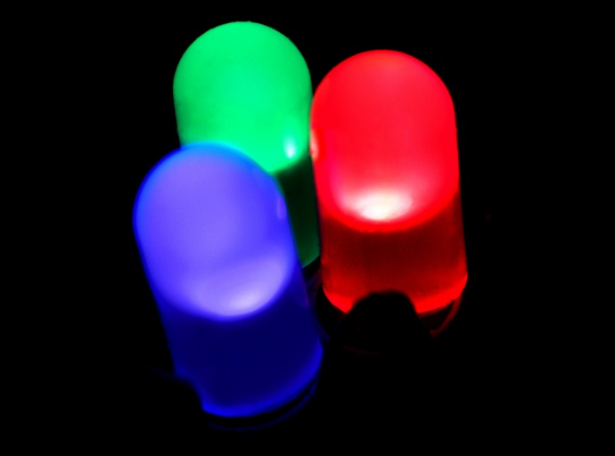

# **Breadboard**

A breadboard is a construction base for prototyping of electronics.

Because the solderless breadboard does not require soldering, it is reusable. This makes it easy to use for creating temporary prototypes and experimenting with circuit design. For this reason, solderless breadboards are also popular with students and in technological education. Older breadboard types did not have this property. A stripboard (Veroboard) and similar prototyping printed circuit boards, which are used to build semi-permanent soldered prototypes or one-offs, cannot easily be reused. A variety of electronic systems may be prototyped by using breadboards, from small analog and digital circuits to complete central processing units (CPUs).

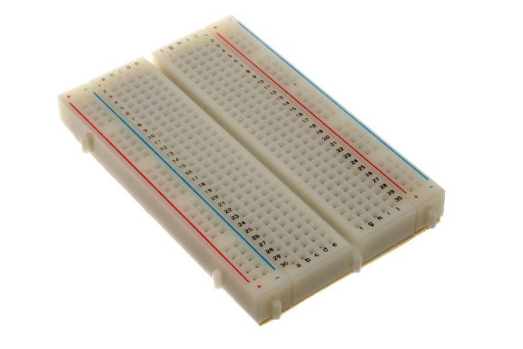

# **Jump wire**

Stranded 22AWG jump wires with solid tips.

A jump wire (also known as jumper, jumper wire, jumper cable, DuPont wire, or DuPont cable – named for one manufacturer of them) is an electrical wire, or group of them in a cable, with a connector or pin at each end (or sometimes without them – simply "tinned"), which is normally used to interconnect the components of a breadboard or other prototype or test circuit, internally or with other equipment or components, without soldering.

Individual jump wires are fitted by inserting their "end connectors" into the slots provided in a breadboard, the header connector of a circuit board, or a piece of test equipment.

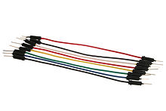

# **Resistance**

Quarter Watt Resistances, 70-150 ohms, depending on the colour of the LED used.

A piece of conducting material of a particular resistance meant for use in a circuit is called a resistor. Resistors are made of a wide variety of materials depending on factors such as the desired resistance, amount of energy that it needs to dissipate, precision, and costs. Our basic need of using a Resistance was to supply the proper amount of voltage required mainly to the LEDs which might otherwise fuse them with a surge.

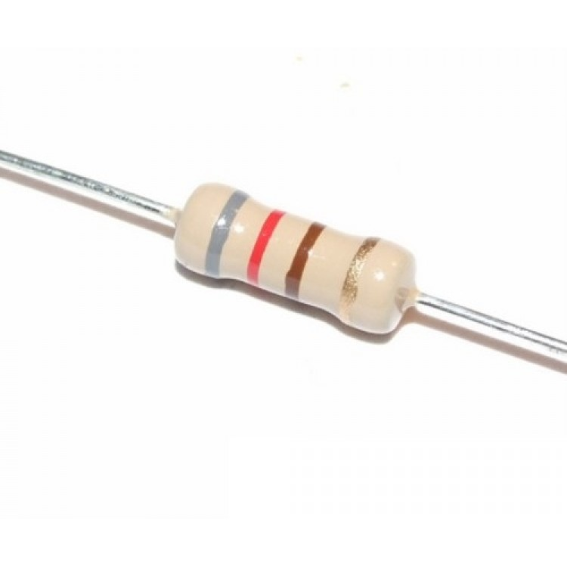

Resistance calculation is done keeping in mind the required potential for an element and the supply provided from the GPIO pins.

LED COLOUR TABLE

|  |  |
| --- | --- |
| COLOUR | OPERATING VOLTAGE AND CURRENT |
| Red | 2.2V, 20mA |
| Green | 3V, 30mA |
| Blue | 3V,30mA |
| White | 3.3V, 25mA |

**TEAM MEMBERS AND CONTRIBUTORS**

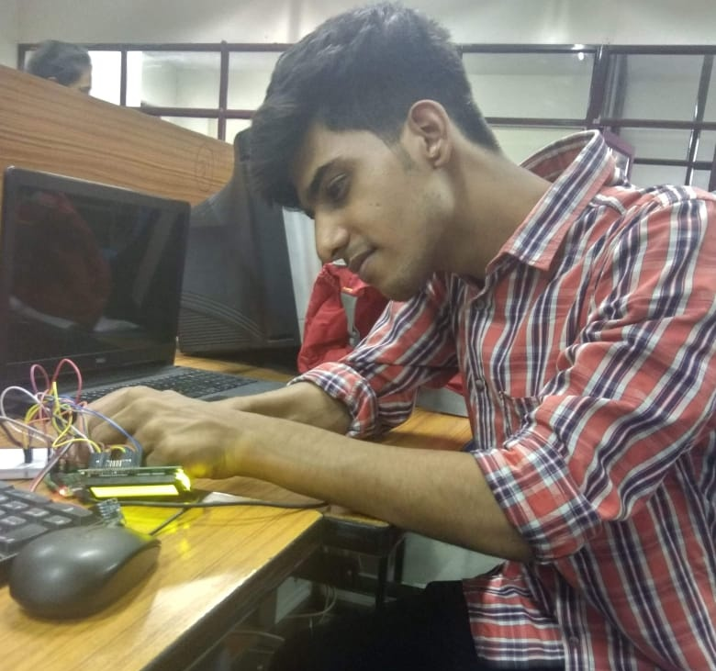 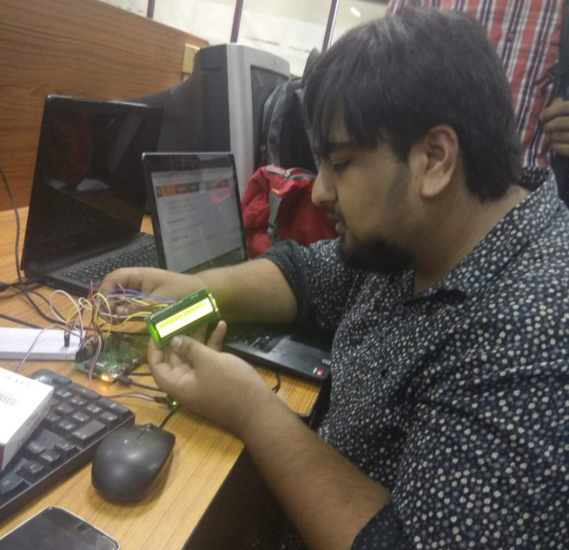

** **

**ACKNOWLEDGEMENTS**

**We would sincerely thank our mentors who have been a constant source of motivation to us, including, but not limited to :**

* Director Sir (NIEC)
* HOD Sir (ECE)
* Mr. Shashank (Sofcon)
* Mr. Ankur Sood (ECE)

OUR TEAM

* SUMNEET KAUR - 07496202816
* AMAN PURI - 35296202816
* ZORAWAR SINGH JAISWAL - 41196202816
* PRANAV GUPTA - 41296202816